SOFTWARE REQUIREMENTS SPECIFICATION
For
Web-Based Student Organization Event Proposal, Approval, and Budget Monitoring Portal in BSIT Pagadian Annex

Prepared by:
ATP NEXT GEN
Antone, Christy Grace C.
Tortal, Larra Mae C.
Patalinghug, Joan Grace M.

Submitted in fulfillment requirements for Integrative Programming and Technologies 2 (IT305)
September 6, 2025
Table of Contents
Table of Contents 2
1. Introduction
1.1 Purpose
1.2 Intended Audience 1
1.3 Product Scope
1.4 Definitions, Acronyms, and Abbreviations
2. Overall Description
2.1 User Characteristics 2
2.2 Constraints 3
2.3 Assumptions and Dependencies 3
3. Requirements Specifications 4
3.1 Functional Requirements 4
3.2 Non-Functional Requirements 4
3.3 External Interface Requirements 6
3.4 System Models 6
3.5 Database Design 7
3.6 Implementation 7
3.7 Testing and Deployment 7
4. Other Requirements 10
4.1 User Manual 10
4.2 Appendices 10

1. Introduction

The Web-Based Student Organization Event Proposal, Approval, and Budget Monitoring Portal is developed to provide a centralized, paperless, and efficient platform for managing PSITS organizational events in BSIT Pagadian Annex. The system aims to streamline proposal submission, approval workflows, and budget monitoring while improving transparency, coordination, and accountability among student officers and advisers.

1.1 Purpose
The purpose of this system is to provide a centralized, paperless, and efficient platform that allows PSITS officers to easily submit event proposals, obtain approvals, and monitor allocated budgets, thereby ensuring smooth coordination and accountability.

1.2 Intended Audience

This document is intended for PSITS officers including the Secretary, Treasurer, President, Adviser, Public Information Officer (PIO), and Students who will interact with the system.

1.3 Product Scope
The system provides an online platform where PSITS Secretary can submit event proposals digitally. These proposals undergo a structured approval process involving the Treasurer, President, and Organization Adviser. The Treasurer reviews and adjusts budget details, the President endorses proposals, and the Adviser provides final approval or rejection. Approved events may be published as announcements by the PIO for student awareness. The system is limited to PSITS organizational activities and does not cover academic or personal financial matters.
In addition, the system maintains records of past proposals, approvals, and financial reports for accountability. Its scope is limited to PSITS-related events and financial tracking within the organization and does not include academic grades, personal finances, or activities of other organizations. To function properly, the system requires internet access and user authentication.

1.4 Definitions, Acronyms, and Abbreviations
- API (Application Programming Interface) – a set of tools and protocols that allows different software components to communicate.
- Approval – The act of reviewing and endorsing a submitted proposal by authorized officers (Treasurer, President, and Adviser).
- BSIT (Bachelor of Science in Information Technology) – the program under which the system is implemented.
- Budget Monitoring – The process of tracking allocated funds and expenses to ensure financial transparency.
- Chart.js – A JavaScript library used for creating interactive charts and visual reports.
- Proposal – A formal request submitted by PSITS officers to organize an event, including objectives, plans, and budget.
- PSITS (Philippine Society of Information Technology Students) – the student organization managing events and proposals.
- User Authentication – The process of verifying a user’s identity to grant access to the system.
- Web-Based System – A software application that can be accessed and used through a web browser over the internet.

2. Overall Description

2.1 User Characteristics
- Target Users: The users of the system include PSITS officers and students.
- Required Skills: Users are expected to possess basic computer literacy, such as navigating web browsers, completing online forms, and retrieving records.
- Expected Experience: Users should have prior experience with organizational responsibilities, including event proposal preparation, approval processes, and budget monitoring.

2.2 Constraints
- Hardware: Requires a computer, laptop, or mobile device with stable internet connectivity.
- Software: Needs a modern web browser (e.g., Google Chrome, Mozilla Firefox, Microsoft Edge, Brave Browser) for proper functionality.
- Regulations: Must comply with PSITS and school policies on event management and financial transparency.
- Standards: Should follow data security standards to safeguard user credentials and financial records.

2.3 Assumptions and Dependencies
Assumptions:
- Users have basic computer literacy and access to internet-enabled devices.
- PSITS officers will use the system according to their assigned roles and responsibilities.
- The school administration will provide support for system implementation and maintenance.
Dependencies:
- Requires stable internet connectivity for real-time access.
- Depends on reliable web hosting and database servers.
- Utilizes Chart.js for generating and displaying visual reports and budget monitoring charts.
3. Specific Requirements
3.1 Functional Requirements
The functional requirements of the system define the specific features that directly support the organizational workflow. The system is intended to provide role-based access to ensure accountability and structured processes in managing proposals and financial requests.

User Authentication and Role-Based Access
The system includes a secure login mechanism through a single interface. Once a user successfully authenticates, their role is automatically identified from the database, and they are redirected to the appropriate dashboard. In this way, each individual is granted access only to functions relevant to their position, which removes the need for manual role selection and prevents unauthorized use.
Proposal Creation
Each proposal contains essential fields such as the event title, event duration, expected participants, budget breakdown, event rationale, supporting documents, and financial estimates. Proposals that formally request approval of the activity are required attachments, while additional materials such as images or screenshots may also be uploaded to reinforce the validity of the proposal.
Proposal Status and Review Workflow
Submitted proposals shall pass through a structured review process involving the Treasurer, President, and Adviser. Proposals may be approved or returned at each stage, while only the Adviser is authorized to issue final approval or rejection.
Budget Management
An estimated budget is submitted by the Secretary alongside the event proposal. The Treasurer then reviews and evaluates this budget before financial allocation is granted If adjustments are required, the Treasurer revises the budget figures and includes remarks explaining the modifications. This process promotes proper negotiation and careful monitoring of financial resources.
Remarks
Both the President and Treasurer are able to provide remarks when budget allocations appear excessive or inappropriate. These remarks are permanently attached to the related proposal record for accountability. The system also indicates alerts if there are new proposals or returned proposals that are needed to review.
3.2 Non-Functional Requirements
The non-functional aspects of the system define the quality standards and constraints under which it shall operate, ensuring not only efficiency but also reliability and user satisfaction.
Performance. The system is designed to process user requests smoothly under normal network conditions while maintaining responsiveness and stability, regardless of the number of active users.
Security. User roles are identified based on account information stored in the database. The system applies authentication mechanisms and role-based access control to ensure that only authorized users can access sensitive records and system functions.
Usability. The interface is intended to be intuitive and user-friendly, enabling officers to navigate the platform with ease. Accessibility through both desktop and mobile devices ensures convenience and flexibility for all users.
Reliability and Availability. The system is designed to remain highly available, with interruptions limited only to scheduled maintenance. To protect data integrity, regular automated backups are performed, reducing the chance of losing information during unexpected failures.
Scalability. The architecture of the system allows for expansion, making it capable of accommodating a growing number of users, event proposals, and budget records without requiring major redesign or redevelopment.
Compatibility. The platform operates effectively across commonly used web browsers such as Google Chrome, Microsoft Edge, and Brave, and performs reliably on both Windows based systems and mobile platforms.

3.3 External Interface Requirements
3.3.1 User Interfaces
The system shall provide a single login page where all users enter their credentials (email & password). After login, the system shall redirect users to their role-based dashboard (President, Secretary, Treasurer, PIO, Adviser, Student).
Each dashboard shall display only the features relevant to the role, for example: President: view all proposals, view recently processed proposals. Secretary: create and submit proposals. Treasurer: review proposals and budget. PIO: create and manage announcements. Adviser: review proposals. Student: view overview of proposals/events.
The system shall be responsive for desktop, laptop, and mobile devices.
3.3.2 Hardware Interfaces
The system shall be accessible via standard computing devices (desktop, laptop) with internet access. The system shall support access via mobile devices (smartphones, tablets). The server hosting the portal shall provide sufficient storage and processing power for proposals, budget records, and reports.
3.3.3 Software Interfaces
The system shall connect to a relational database (MySQL) to store user accounts, proposals, approvals, budgets, reports, and announcements. The system uses native PHP to manage backend logic and database interactions without relying on a full-stack web framework.
3.3.4 Communication Interfaces
The system shall be accessible through the internet or campus network using HTTP or HTTPS, depending on the hosting configuration. Proposal status changes are reflected upon page refresh after user actions.

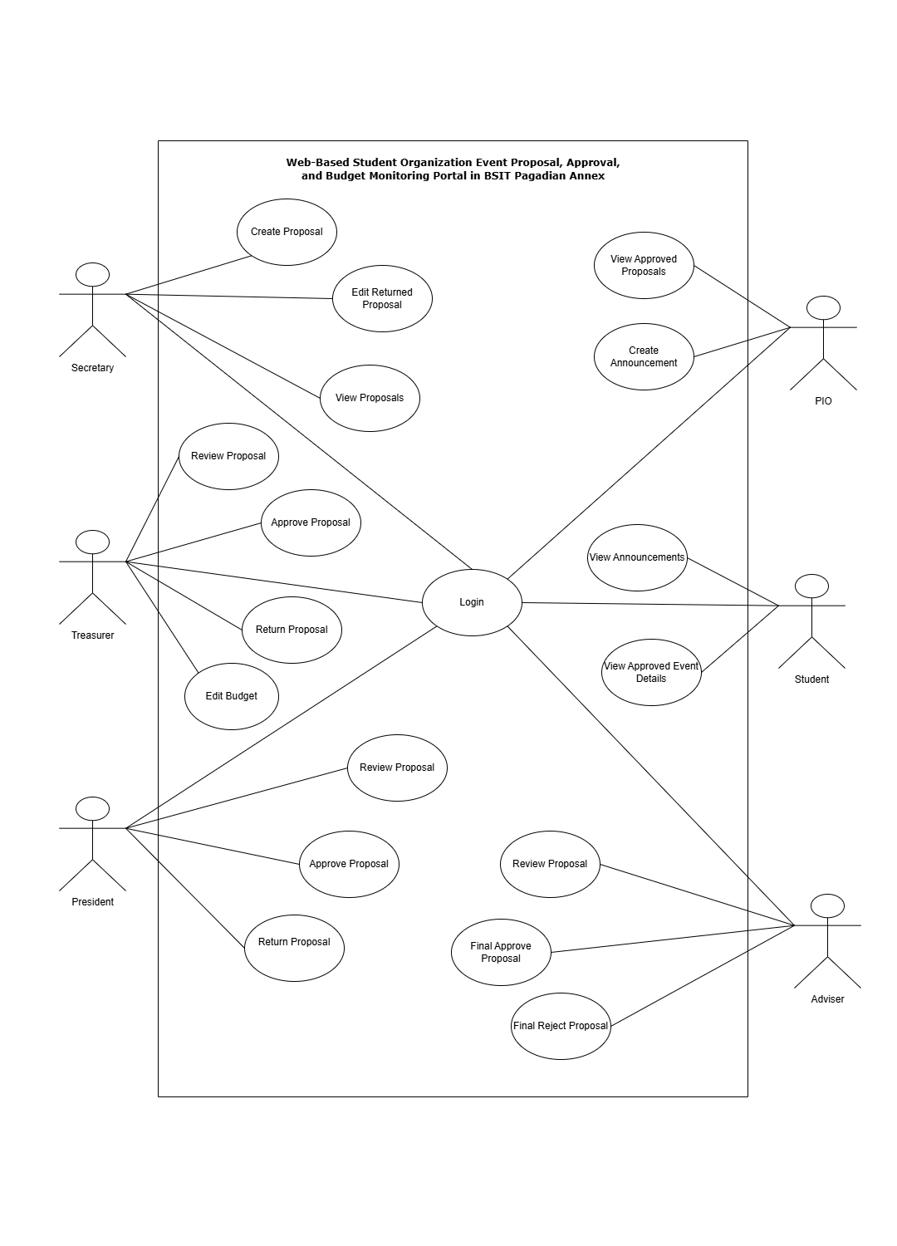
3.4 System Models
UML Use Case

3.5 Database Design
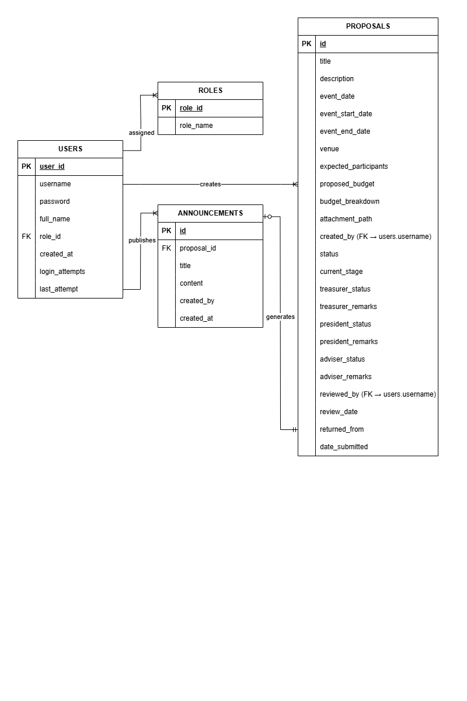
Entity-Relationship Diagram
3.6 Implementation
- The system is developed as a web-based application for managing event proposals, approval workflows, and budget monitoring.
- The frontend is implemented using PHP with embedded HTML, along with CSS and JavaScript, allowing dynamic content rendering based on user roles and system data.

- The backend is developed using PHP, which handles:
  - user authentication and session management
  - role-based access control
  - proposal submission and multi-stage approval logic
- The database is implemented using MySQL (MariaDB) to store user records, roles, proposals, approval details, and announcements.
- The development environment includes:
  - a local web server such as XAMPP
  - phpMyAdmin for database management
  - a source code editor such as Visual Studio Code
- The system uses native PHP without a full-stack framework, ensuring direct control over application logic and database operations.
- Proposal attachments are processed through PHP file upload handling and stored in a designated uploads directory.
3.7 Testing and Deployment
Testing
- The system underwent functional testing to ensure that all core features—such as proposal submission, review workflows, approval actions, budget updates, and announcement creation—operate correctly.
- Role-based testing was conducted to verify that each user role (Secretary, Treasurer, President, Adviser, PIO, and Student) can only access the functionalities assigned to them.
- Workflow testing was performed to validate the correct movement of proposals through the approval stages, including submission, return, approval, and final decision.
    - Load Test
Load testing was conducted to evaluate system performance under normal and peak usage conditions.
  - The test simulated 408 student users and 5 officers (413 users total) accessing the system concurrently.
  - Results showed that the system maintained stable performance with an average response time of less than 9 milliseconds, and no functional errors were encountered.
Table 1: Load Test Performance Metrics
Simulated Load (Users) | Average Response Time (ms) | System Performance Observation
10,000 Records | 1,435 | Login and core features remain functional under heavy load. System remains stable but noticeable delay is observed during authentication and dashboard loading.
10,000 Records | 1,700 | Slight delay in dashboard rendering and page transitions. User actions such as submission still complete successfully without errors.
416 Records | 300 | No errors encountered. All features function correctly. Dashboard loads quickly with minimal delay, indicating optimal performance under low data volume.

    - Stress Test
Stress Testing was performed to determine the system’s breaking point and behavior under extreme conditions.
Concurrent officer actions such as proposal reviews, approval decisions, file uploads, and budget analytics were simulated.
As the number of concurrent operations increased, response times gradually degraded, but the system remained operational and recovered successfully once the load was reduced.
Table 1: Stress Test Performance and Breaking Point Analysis
Database Load | Concurrent Users & Actions | System Response | Observation & Failure Mode
416 student records + 5 officers | 49 concurrent users (Secretary, Treasurer, President, Adviser, PIO, Students) accessing dashboards and workflows | Avg response time 112 ms, spikes up to 2–3 seconds | System shows instability under peak load; high error rate observed during concurrent access
250,000 total requests | Full workflow execution (proposal creation, approvals, announcement posting) + student dashboard access | High throughput but 44% failed requests | Breaking point reached; system partially overwhelmed under sustained stress
Recovery Test (Reduced Load) | Reduced concurrent users and request volume | Normal response restored (< 300 ms) | System successfully recovers after load reduction

Note: Officer workflows simulated in this test are role-based. Only Secretary, President, Adviser, and Treasurer have access to 'review_proposal.php'. File uploads, and review actions (approve, reject, return) were executed in JMeter through parameterized CSV inputs.
Stress load was generated with JMeter thread groups simulating simultaneous user flows using your actual user data.
    - Beta Test
Beta Testing the final stage of software testing where a near-final product is released to a limited group of real users (beta testers) to test in real-world conditions before its official launch, allowing developers to find hidden bugs, usability issues, and gather crucial feedback for improvements.
    - User Acceptance Test (UAT)
Testing Criteria
Table – Questionnaire Range and Description
Range | Quantitative Description
1 | Strongly Disagree
2 | Disagree
3 | Neutral
4 | Agree
5 | Strongly Agree
Questions | 1 | 2 | 3 | 4 | 5
- The system allowed me to complete my assigned tasks. (Functionality)
- I understood where to click to perform my tasks. (Usability / Navigation)
- The information shown on the screens was clear and accurate. (Information quality)
- Proposal statuses (Pending, Returned, Approved, etc.) updated correctly after my actions. (Logic / Flow correctness)
- The system’s speed and response time were acceptable. (Performance)
- Overall, the system was easy to use. (Overall usability)
Table – Feedback and Evaluation

Table – Secretary Section
Questions | 1 | 2 | 3 | 4 | 5
- It was easy to create and submit an event proposal.
- The fields for event details, description, and budget were clear and complete.

Table – Treasurer Section
Questions | 1 | 2 | 3 | 4 | 5
- It was easy to review the event details and budget as Treasurer.
- The remarks and status updates for proposals were clear to me.

Table – President Section
Questions | 1 | 2 | 3 | 4 | 5
1. It was easy to review proposals endorsed by the Treasurer.
2. Forwarding or returning proposals with remarks was straightforward.

Table – Adviser Section
Questions | 1 | 2 | 3 | 4 | 5
1. I could see all important information needed for final approval or rejection.
2. The process for giving final approval or rejection was clear.

Table – PIO Section
Questions | 1 | 2 | 3 | 4 | 5
1. It was easy to view approved proposals for announcement purposes.
2. Creating an announcement based on an event was simple and clear.

Table – Student Section
Questions | 1 | 2 | 3 | 4 | 5
- I clearly understood the event details shown in the system.
2. The approved budget display helped me understand the transparency of funds.

Testing
The following shows the exact number of respondents who selected each rating using the 5-likert scale. (1=Strongly Disagree, 2=Agree, 3=Neutral, 4=Disagree, 5=Strongly Disagree).
Table – Secretary Section
Questions | 1 | 2 | 3 | 4 | 5
- It was easy to create and submit an event proposal. |  |  |  |  | 1
- The fields for event details, description, and budget were clear and complete. |  |  |  |  | 1

Table – Treasurer Section
Questions | 1 | 2 | 3 | 4 | 5
- It was easy to review the event details and budget as Treasurer. |  |  | 1
- The remarks and status updates for proposals were clear to me. |  |  |  |  | 1

Table – President Section
Questions | 1 | 2 | 3 | 4 | 5
1. It was easy to review proposals endorsed by the Treasurer. |  |  |  |  | 1
2. Forwarding or returning proposals with remarks was straightforward. |  |  |  |  | 1

Table – Adviser Section
Questions | 1 | 2 | 3 | 4 | 5
1. I could see all important information needed for final approval or rejection. |  |  |  |  | 1
2. The process for giving final approval or rejection was clear. |  |  |  |  | 1

1
Table – PIO Section
Questions | 1 | 2 | 3 | 4 | 5
1. It was easy to view approved proposals for announcement purposes. |  |  |  |  | 1
2. Creating an announcement based on an event was simple and clear. |  |  |  |  | 1

Table – Student Section
Questions | 1 | 2 | 3 | 4 | 5
- I clearly understood the event details shown in the system. |  | 1 | 2 | 9 | 14
2. The approved budget display helped me understand the transparency of funds. |  | 1 | 2 | 9 | 14

Table – Feedback and Evaluation
Questions | 1 | 2 | 3 | 4 | 5
- The system allowed me to complete my assigned tasks. (Functionality) |  |  | 4 | 11 | 15
- I understood where to click to perform my tasks. (Usability / Navigation) |  |  | 3 | 12 | 15
- The information shown on the screens was clear and accurate. (Information quality) |  |  | 5 | 10 | 15
- Proposal statuses (Pending, Returned, Approved, etc.) updated correctly after my actions. (Logic / Flow correctness) |  |  | 4 | 11 | 15
- The system’s speed and response time were acceptable. (Performance) |  | 1 | 4 | 5 | 20
- Overall, the system was easy to use. (Overall usability) |  | 1 | 2 | 9 | 18

Pie Charts
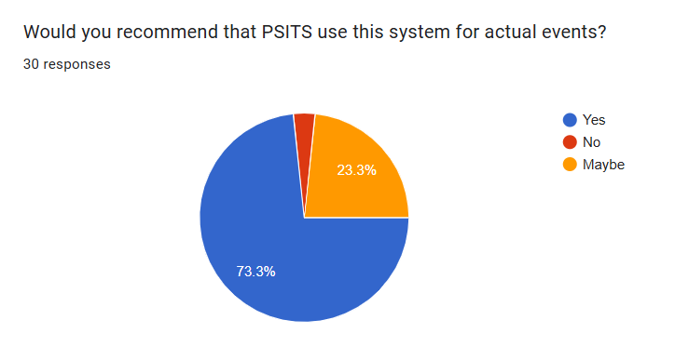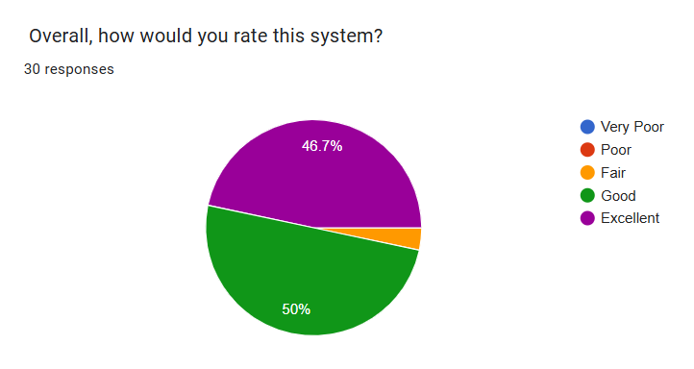

Based on the feedback and evaluation we conducted through Google Forms, the PSITS Event and Budget Monitoring Portal received the following findings:
Key Findings:
- Excellent Performance: Most sections (Secretary, Treasurer, President, Adviser, PIO) received perfect 5.0 averages from their single respondents
- Strong Student Feedback: Students rated the system at 4.38 for both understanding event details and budget transparency
- High Usability Scores: Overall usability scored 4.47, with navigation at 4.40/5
- Good Performance: System performance received the highest rating among general feedback at 4.47
- Areas for Improvement: Treasurer's review process scored lower (3.0) and information quality scored relatively lower at 4.33
Success Metrics:
- Overall Average Score: 4.56 across all quantitative questions
- High Satisfaction: 88% of ratings were 4 or 5 (Agree or Strongly Agree)
- Strong Recommendation: Based on the beta testing results, most users would recommend the system for actual use.
Conclusion:
The PSITS Event Budget and Monitoring Portal has been successfully tested and validated through comprehensive UAT. The system demonstrates:
- Functional Effectiveness: Scores above 4.3 in all major categories confirm the system meets its intended purposes
- User Acceptance: High ratings across role-specific and general feedback indicate strong user satisfaction
- Role-Based Success: Each user role found their specific tasks manageable and intuitive.
Deployment
- The system is initially deployed on a local development environment using a web server such as XAMPP for development and testing purposes.
- After successful testing, the system can be deployed to an online web hosting environment that supports PHP and MySQL.
- Configuration files are updated to match the deployment environment, including database connection settings.
- The system is made accessible to users through a web browser using a designated domain or hosting URL.
- Regular backups of the database and uploaded files are recommended to ensure data availability and recovery.

